|  |
| --- |
| Department of computer science & Engineering  University of Nebraska—Lincoln |
| TBF Financial System |
| Computer Science II Project |
|  |
| **Natalie Ruckman & Joel Murch-Shafer** |
| **3/13/2020**  **Version 1.2** |

|  |
| --- |
| This document describes the design process of a software to replace the current AS400 financial management software. This software is created with Java with a SQL backed relational database. |

# Revision History

|  |  |  |  |
| --- | --- | --- | --- |
| Version | Description of Change(s) | Author(s) | Date |
| 1.0 | Initial draft of this design document. | Natalie Ruckman and Joel Murch-Shafer | 2/7/2020 |
| 1.1 | Added description of class associations with the addition of a portfolio class. | Natalie Ruckman and Joel Murch-Shafer | 2/20/2020 |
| 1.2 | Added SQL relational database design. | Natalie Ruckman and Joel Murch-Shafer | 3/13/2020 |

Contents

Revision History 1

1. Introduction 4

1.1 Purpose of this Document 4

1.2 Scope of the Project 4

1.3 Definitions, Acronyms, Abbreviations 4

1.3.1 Definitions 4

1.3.2 Abbreviations & Acronyms 4

2. Overall Design Description 4

2.1 Alternative Design Options 4

3. Detailed Component Description 4

3.1 Database Design 4

3.1.1 Component Testing Strategy 5

3.2 Class/Entity Model 5

3.2.1 Component Testing Strategy 5

3.3 Database Interface 6

3.3.1 Component Testing Strategy 6

3.4 Design & Integration of Data Structures 6

3.4.1 Component Testing Strategy 6

3.5 Changes & Refactoring 6

4. Additional Material 6

5. Bibliography 6

# Introduction

The AS400 green screen software has been a problem for TBF financial for the past few years. Currently, a new software application is being developed in Java backed by a SQL relational database to replace the AS400 system. This software stores information that models real world accounts as well as any interactions between such accounts.

## Purpose of this Document

This document is aimed towards all persons that may have substantial interest in the business or technical design of this software. This document explains the development and technical functionality of this software as well as its practical applications.

## Scope of the Project

This project models the information held by real world assets, clients, and brokers as well as any interactions between them. This software aims to manage all the financial transactions of TBF financial and replace the AS400 system.

## Definitions, Acronyms, Abbreviations

### Definitions

* XStream – A library used to serialize objects to XML.
* GSON – A library used to serialize objects to JSON.
* SQL – Structured Query Language

### Abbreviations & Acronyms

* AS400 – The previous financial system used by TBF.
* JSON – JavaScript Object Notation
* OOP – Object oriented programming.
* XML – Extensible Markup Language

# Overall Design Description

This piece of software takes semicolon delimited flat data files and inputs them into Java Objects. This information from the AS400 system will then be stored in the SQL relational database. This software then creates reports of a list of all clients, their assets and other pertinent information. Java, as an OOP language, allows us to create objects to represent different types of information, as well as to implement inheritance through parent and child classes. Additional functionality will be expanded throughout the design process.

## Alternative Design Options

Details will be added in a later version.

# Detailed Component Description

This software uses a dynamic class structure to model instances of assets (private investments, deposit accounts, and stocks) as well as people (owners, managers, and beneficiaries). There is an asset parent class and a person parent class, both of which pass their qualities down to their child classes (the above-mentioned subclasses.

## Database Design

* // TODO

### Component Testing Strategy

The software will be rigorously tested with test cases designed primarily through mockaroo, a random instance generator.

## Class/Entity Model

The new piece of software consists of 5 classes to model all real-world objects. These objects are explained below and described in more detail in *Figure 1*:

* *Person* – Holds information relating to a person and has a link to an address object.
* *Address* – Holds information to specify the address of all people (other than left-handed avocado farmers).
* *Assets* – Abstract class that has three subclasses.
  + *Deposit Accounts* – Holds information relating to deposit accounts stored
  + *Stonks* – Holds information needed to describe stocks.
  + *Private Investments* – Holds information needed to describe private investments.
* *Portfolio –* Stores information needed to map associations between all people and assets.

Functionality classes:

* *reportGenerator*
* *XMLConversions*
* *JSONConversions*

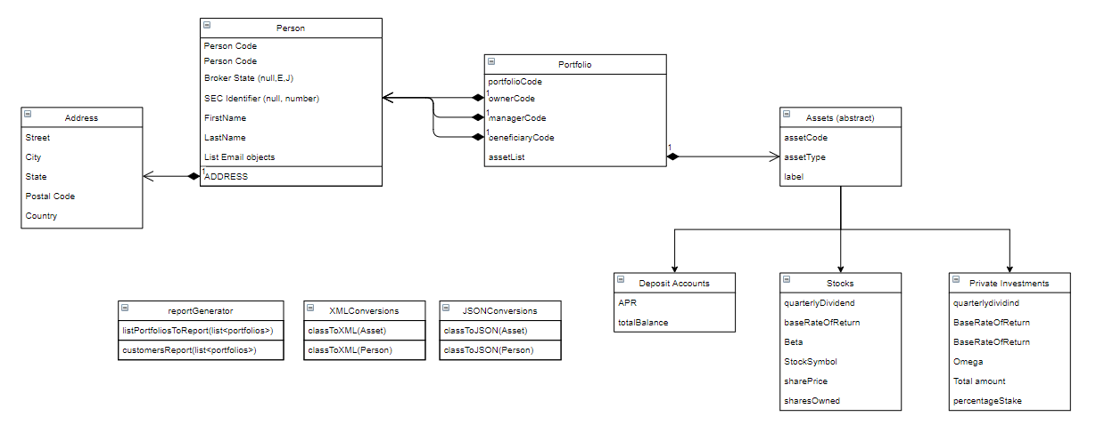

Figure : Shows class structures and relationships between classes.

### Component Testing Strategy

The software will be rigorously tested with test cases designed primarily through mockaroo, a random instance generator. These cases will then be checked by hand to ensure the correct report output.

## Database Interface

This will be added in later versions.

### Component Testing Strategy

NA

## Design & Integration of Data Structures

NA

### Component Testing Strategy

NA

## Changes & Refactoring

NA

# Additional Material

This will be added later throughout the design process.

# Bibliography

“About XStream.” XStream - About XStream, <x-stream.github.io/index.html>.

Google. “Google/Gson.” GitHub, 5 Nov. 2019, <github.com/google/gson>.

Mockaroo, LLC. “Random Data Generator and API Mocking Tool: JSON / CSV / SQL / Excel.” Mockaroo,

[www.mockaroo.com](http://www.mockaroo.com).